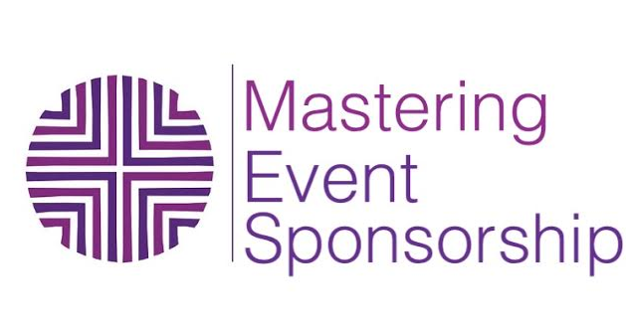

**CLASS 1: GET CLEAR OF YOUR WHY (YOUR INTENTION)**

**PLAN AND OUTLINE THE LOGISTICS**

**WHY do you want to create this event?**

***EX:*** *My intention is that I have an event so I can have a ton of prospects for my 1 on 1 program.*

**YOUR INTENT WILL DEFINE MOST OF YOUR LOGISTICS AND YOUR PROMOTIONS AND MARKETING**

**Do you see any lack of clarity or conflict with your intention?**

*EX: “ a ton of”*

**If so then – make some adjustments here:**

EX: “20 - 30 new prospects for my 1 on1 program”

**Attach a SMART GOAL to your intention**

SMART means: Specific, Measurable, Action Driven, Results oriented, Time Bound

EX: I will have an event that will bring at least 30 attendees of which 15 will sign up for a sales call with me that will happen within a month of the event and will allow me to sign up 10 new clients by March of 2016.

**Write out your SMART goal:**

**USEFUL TIPS**

*For events where you want to have many people to bring into your next offer, shoot for high attendance and lower ticket price.*

*Keeping pricing on the lower end will help you make ticket registration/selling easier.*

*For events where you want to make money, having more attendees will support you in selling sponsorship.*

**PLAN AND OUTLINE THE LOGISTICS**

You will use most of this information when crafting your sponsor attractive proposal or deck.

WHEN

WHERE

WHO – YOUR ATTENDEE PROFILE*

AGE RANGE

GENDER

TYPE OF WORK

INTERESTS

HW

1. Research locations for your event

2. Transcribe written notes into digital format

3. Start to organize information, make a folder on your computer desktop, easily locate it

4. Start to get a clear picture of what your event would look like, visualize it in your mind for 5 minutes every day.